***Sec. 5-1 (p.271)***

* ***determine whether the distribution represents a probability distribution. If it does not, state why.***

|  |  |  |  |  |  |  |  |  |  |
| --- | --- | --- | --- | --- | --- | --- | --- | --- | --- |
| **8.** | |  |  |  |  | | --- | --- | --- | --- | |  | 5 | 7 | 9 | |  | 0.6 | 0.8 | -0.4 | |

No, probability values cannot be negative. (機率值不可為負)

|  |  |  |  |  |  |  |  |  |  |  |  |
| --- | --- | --- | --- | --- | --- | --- | --- | --- | --- | --- | --- |
| **11.** | |  |  |  |  |  | | --- | --- | --- | --- | --- | |  | 3 | 6 | 9 | 1 | |  | 0.3 | 0.4 | 0.3 | 0.1 | |

No, the sum of the probabilities is greater than 1. (機率值加總超過1)

* ***state whether the variable is discrete or continuous.***

|  |  |
| --- | --- |
| **14.** | The number of people who play the state lottery each day.  (每天玩州彩票的人數) |

Discrete. 人數為無限數量可數的值

|  |  |
| --- | --- |
| **16.** | The time it takes to have a medical physical exam.  (進行體檢所需的時間) |

Continuous. 時間為測量的數值

* ***construct a probability distribution for the data and draw a graph for the distribution.***

|  |  |
| --- | --- |
| **20.** | **Investment Return**  The probabilities of a return on an investment (投資回報) of $5000, $7000, and $9000 are $\frac{1}{2}$, $\frac{3}{8}$ and $\frac{1}{8}$, respectively. |

|  |  |  |  |
| --- | --- | --- | --- |
|  | $5,000 | $7,000 | $9,000 |
| $$P\left(X\right)$$ | $$\frac{1}{2}$$ | $$\frac{3}{8}$$ | $$\frac{1}{8}$$ |

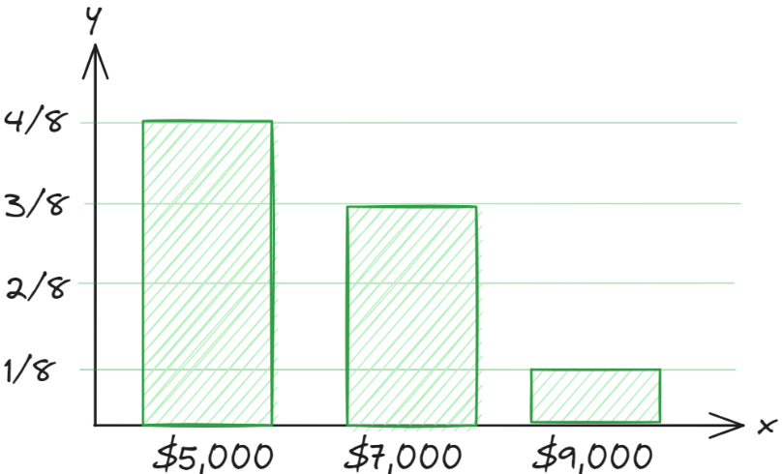

|  |  |
| --- | --- |
| **24.** | **Item Selection**  The probabilities that a customer selects 1, 2, 3, 4, and 5 items at a convenience store are 0.32, 0.12, 0.23, 0.18, and 0.15, respectively. |

|  |  |  |  |  |  |
| --- | --- | --- | --- | --- | --- |
|  | 1 | 2 | 3 | 4 | 5 |
| $$P\left(X\right)$$ | 0.32 | 0.12 | 0.23 | 0.18 | 0.15 |

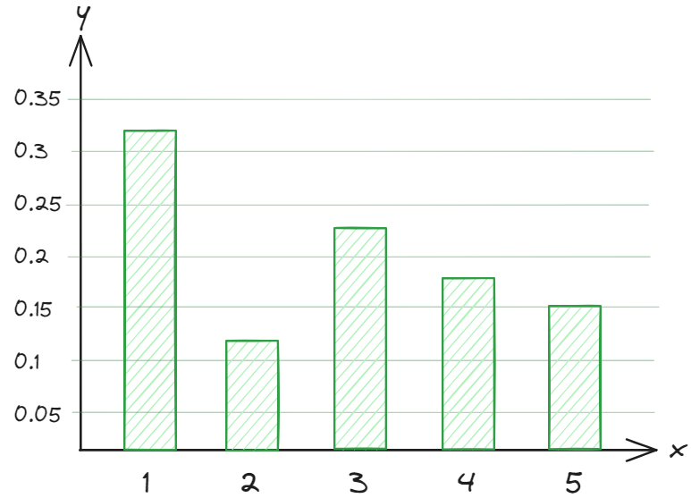

|  |  |
| --- | --- |
| **30.** | **Mathematics Tutoring Center**  At a drop-in mathematics tutoring center (臨時數學輔導中心), each teacher sees 4 to 8 students per hour. The probability that a tutor sees 4 students in an hour is 0.117; 5 students, 0.123; 6 students, 0.295; and 7 students, 0.328. Find the probability that a tutor sees 8 students in an hour, construct the probability distribution, and draw the graph. |

|  |  |  |  |  |  |
| --- | --- | --- | --- | --- | --- |
|  | 4 | 5 | 6 | 7 | 8 |
| $$P\left(X\right)$$ | 0.117 | 0.123 | 0.295 | 0.328 | 1-P(4,5,6,7)  =1-.863=0.137 |

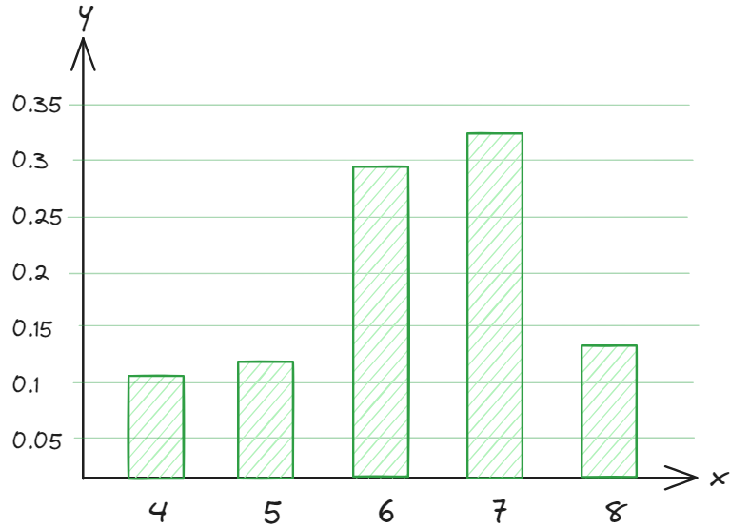

***Sec. 5-2 (p.280)***

|  |  |  |  |  |  |  |  |  |  |  |  |  |  |
| --- | --- | --- | --- | --- | --- | --- | --- | --- | --- | --- | --- | --- | --- |
| **9.** | **Automobiles**  A survey shows the probability of the number of automobiles (汽車) that families in a certain housing plan own. Find the mean, variance, and standard deviation for the distribution.   |  |  |  |  |  |  | | --- | --- | --- | --- | --- | --- | |  | 1 | 2 | 3 | 4 | 5 | |  | 0.27 | 0.46 | 0.21 | 0.05 | 0.01 | |

Mean: $μ=∑X⋅P\left(X\right)=2.07$

Variance: $σ^{2}=∑\left[X^{2}P\left(X\right)\right]-μ^{2}=5.05-{2.07}^{2}=0.7651$

Standard deviation: $σ=\sqrt{σ^{2}}=\sqrt{0.7651}≈0.875$

|  |  |  |  |  |  |  |  |  |  |  |  |
| --- | --- | --- | --- | --- | --- | --- | --- | --- | --- | --- | --- |
| **12.** | **Job Bids**  A landscape contractor (承包商) bids (競標) on jobs where he can make $3000 profit. The probabilities of getting 1, 2, 3, or 4 jobs per month are shown.   |  |  |  |  |  | | --- | --- | --- | --- | --- | | **Number of jobs** | 1 | 2 | 3 | 4 | | **Probability** | 0.2 | 0.3 | 0.4 | 0.1 |   Find the contractor’s expected profit per month. |

|  |  |
| --- | --- |
| **15.** | **Lottery Prize**  A lottery offers one $1000 prize, one $500 prize, and five $100 prizes. One thousand tickets are sold at $3 each. Find the expectation if a person buys one ticket. |

* 注意買彩券的成本

|  |  |  |  |  |
| --- | --- | --- | --- | --- |
| **Earned money** | $1000 - $3 = $997 | $500 - $3 = $497 | $100 - $3 = $97 | $0 - $3 = -$3 |
| **Probability** | 1/1000=0.001 | 0.001 | 0.005 | 0.993 |

|  |  |  |  |  |  |  |  |  |  |  |  |  |  |  |  |  |  |  |  |  |  |  |
| --- | --- | --- | --- | --- | --- | --- | --- | --- | --- | --- | --- | --- | --- | --- | --- | --- | --- | --- | --- | --- | --- | --- |
| **19.** | **Roulette**  A roulette wheel (賭盤) has 38 numbers, 1 through 36, 0, and 00. One-half of the numbers from 1 through 36 are red, and the other half are black; 0 and 00 are green. A ball is rolled, and it falls into one of the 38 slots, giving a number and a color. The payoffs (回報) (winnings) for a $1 bet (賭注) are as follows:   |  |  |  |  | | --- | --- | --- | --- | | Red or black | $1 | 0 | $35 | | Odd or even | $1 | 00 | $35 | | 1-18 | $1 | Any single number | $35 | | 9-36 | $1 | 0 or 00 | $17 |   If a person bets $1, find the expected value for each.   |  |  |  |  |  | | --- | --- | --- | --- | --- | | 1. Red | 1. Even | 1. 00 | 1. Any single number | 1. 0 or 00 | |

賭盤總共38格，1到36中，18格紅色，18格黑色，0和00為綠色

$P\left(red\right)=\frac{18}{38}⋅\$1+\frac{20}{38}⋅\left(-\$1\right)=\frac{-\$2}{38}≈-\$0.0526$

$P\left(even\right)=\frac{18}{28}⋅\$1+\frac{20}{38}⋅\left(-\$1\right)=\frac{-\$2}{38}≈-\$0.0526$

$P\left(00\right)=\frac{1}{38}⋅\$35+\frac{37}{38}⋅(-\$1)=\frac{-\$2}{38}≈-\$0.0526$

$P\left(any single number\right)\frac{1}{38}⋅\$35+\frac{37}{38}⋅(-\$1)=\frac{-\$2}{38}≈-\$0.0526$

(投注一個數字)

$P\left(0 or 00\right)=\frac{2}{38}⋅\$17+\frac{36}{38}⋅\left(-\$1\right)=\frac{-\$2}{38}≈-\$0.0526$

***Sec. 5-3 (p.290)***

|  |  |
| --- | --- |
| **2.** | Which of the following are binomial experiments or can be reduced to binomial experiments?   1. Testing one brand of aspirin (阿司匹林) by using 10 people to determine whether it is effective 2. Asking 100 people if they smoke 3. Checking 1000 applicants (申請者) to see whether they were admitted to White Oak (橡樹) College 4. Surveying 300 prisoners (囚犯) to see how many different crimes (罪刑) they were convicted of (觸犯) 5. Surveying 300 prisoners to see whether this is their first offense (初犯) |

Binomial: 固定的次數、兩種結果、試驗之間獨立、成功機率相同

1. Yes (兩個結果: 有效、無效
2. Yes (兩個結果: 有抽菸、沒抽菸
3. Yes (兩個結果: 錄取、沒錄取
4. No (罪刑多於兩種結果
5. Yes (兩個結果: 初犯、不是初犯

|  |  |
| --- | --- |
| **10.** | **High School Dropouts**  Approximately 10.3% of American high school students drop out of school (輟學) before graduation. Choose 10 students entering high school at random. Find the probability that   1. No more than 2 drop out 2. At least 6 graduate 3. All 10 stay in school and graduate |

(兩種結果: 輟學、沒輟學) $n=10$，令 $X$ 為輟學的人數，輟學的機率: $p=0.103$



$P\left(X≤2\right)=P\left(0\right)+P\left(1\right)+P\left(2\right)$ $=\frac{10!}{10!0!}{\left(0.103\right)}^{0}{\left(1-0.103\right)}^{10}+\frac{10!}{9!1!}{\left(0.103\right)}^{1}{\left(1-0.103\right)}^{9}+\frac{10!}{8!2!}{\left(0.103\right)}^{2}{\left(1-0.103\right)}^{8}$ $≈0.337+0.387+0.200=0.924$

$P\left(X≤4\right)=P\left(0\right)+P\left(1\right)+P\left(2\right)+P\left(3\right)+P(4)$ $=P\left(X≤2\right)+\frac{10!}{7!3!}{\left(0.103\right)}^{3}{\left(1-0.103\right)}^{7}+\frac{10!}{6!4!}{\left(0.103\right)}^{4}{\left(1-0.103\right)}^{6}$ $≈0.924+0.061+0.012=0.997$

$P\left(X=0\right)=\frac{10!}{10!0!}{\left(0.103\right)}^{0}{\left(1-0.103\right)}^{10}≈0.337$

|  |  |
| --- | --- |
| **16.** | **Guidance Missile System**  A missile guidance system (飛彈導引系統) has 5 fail-safe components (故障保護裝置). The probability of each failing is 0.05. Find these probabilities.   1. Exactly 2 will fail. 2. More than 2 will fail. 3. All will fail. 4. Compare the answers for parts a, b, and c, and explain why these results are reasonable. |

(兩種結果: 故障、沒故障) $n=5$，令 $X$ 為故障的個數，故障的機率: $p=0.05$

$P\left(X=2\right)=\frac{5!}{2!3!}{\left(0.05\right)}^{2}{\left(1-0.05\right)}^{3}≈0.021$

$P\left(X>2\right)=1-P\left(X≤2\right)=1-\left[P\left(0\right)+P\left(1\right)+P\left(2\right)\right]$ $=1-\left[\frac{5!}{0!5!}{\left(0.05\right)}^{0}{\left(1-0.05\right)}^{5}+\frac{5!}{1!4!}{\left(0.05\right)}^{1}{\left(1-0.05\right)}^{4}+\frac{5!}{2!3!}{\left(0.05\right)}^{2}{\left(1-0.05\right)}^{3}\right]$ $≈1-\left(0.774+0.204+0.021\right)=0.001$

$P\left(X=5\right)=\frac{5!}{5!0!}{\left(0.05\right)}^{5}{\left(1-0.05\right)}^{0}≈0$

2. The answers are reasonable because the probability any component will fail is very small (0.05). The probabilities of more than one part failing get increasingly smaller.

|  |  |
| --- | --- |
| **21.** | In 2014 the percentage of the U.S. population who was foreign-born (國外出生的) was 13.1. Choose 60 U.S. residents (居民) at random. How many would you expect to be American-born? Find the mean, variance, and standard deviation for the number who are foreign-born |

(兩種結果: 美國出生、不在美國出生) $n=60$，令 $X$ 為國外出生的人數，國外出生的機率: $p=0.131$

1. 美國出生的預期人數: $μ=n\left(1-p\right)=60⋅(1-0.131)=52.14$
2. 國外出生的人數之

平均: $μ=np=60⋅0.131=7.86$

變異數: $σ^{2}=npq=60⋅0.131⋅\left(1-0.131\right)≈6.83$

標準差: $σ=\sqrt{6.83}≈2.61$

|  |  |
| --- | --- |
| **28.** | Thirty-two percent of adult Internet users have purchased products or services online. For a random sample of 200 adult Internet users, find the mean, variance, and standard deviation for the number who have purchased goods or services online. |

(兩種結果: 買過網路服務或產品、沒有買過網路服務或產品)

$n=200$，令 $X$ 為買過網路服務或產品的人數，買過網路服務或產品的機率: $p=0.32$

Mean: $μ=np=200⋅0.32=64$

Variance: $σ^{2}=npq=200⋅0.32⋅0.68=43.52$

Standard deviation: $σ=\sqrt{43.52}≈6.60$